Jenkins-assignment 7:
Build and package .war file https://github.com/Shantanumajan6/project and https://github.com/Shantanumajan6/myapp-project on Jenkins master. On another EC2-instance install Java start tomcat manually and deploy .war file from Jenkins Master to another EC2. Note: this is not master slave connection
------------------------------------------------------------------------------------------------------------------
Clone LoginWebapp and myProject repo in 2 diff Folders
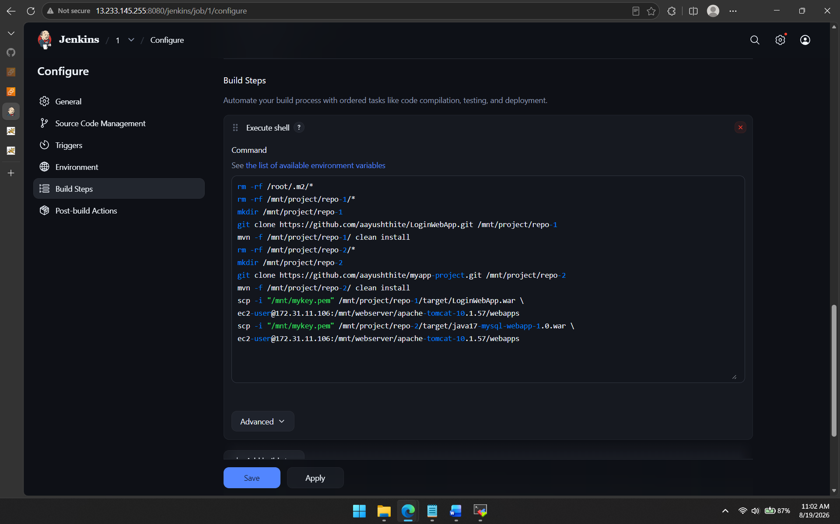
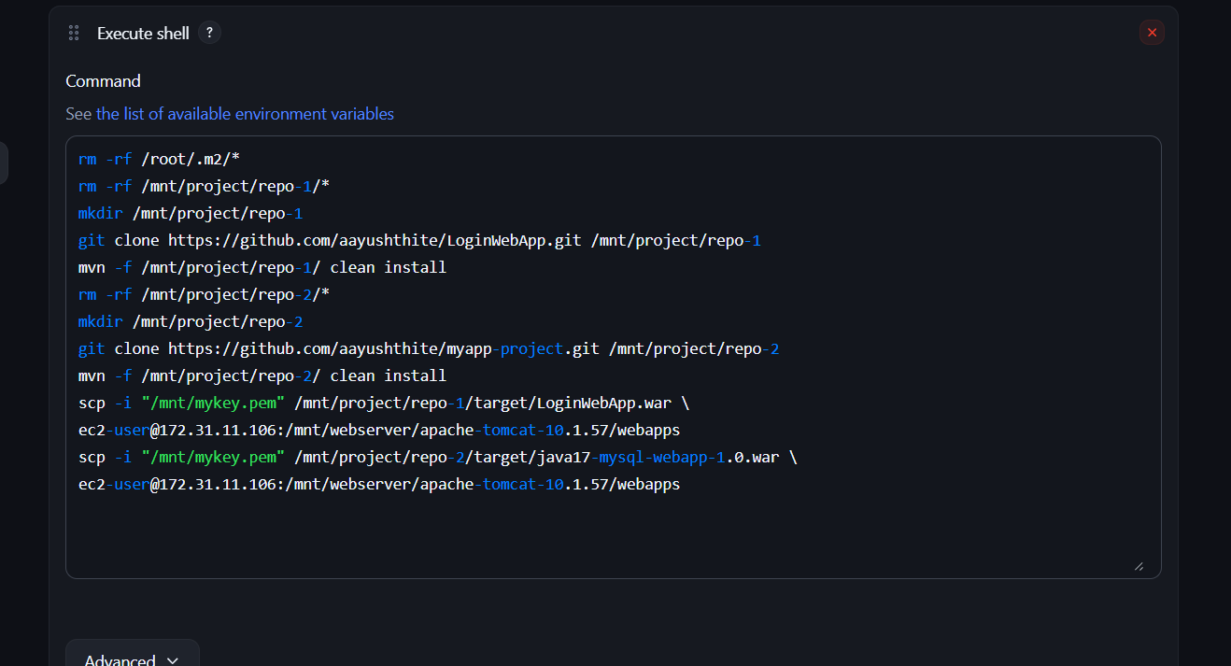
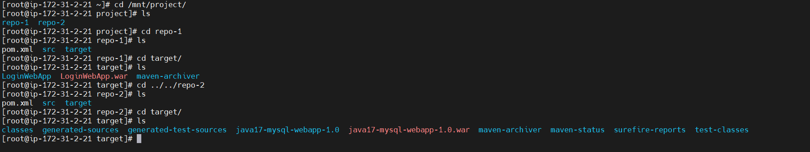
Compiled and package with command mvn -f /pathof-pom.xml clean install into specified repo-1 and repo-2
Next with the help of scp command copied those .war files into another ec2-instance and deployed into tomcat/webapps

